Name: Majid Ali
CMS ID: 053-25-0017
Course: Java (Lab: 7)

Task No: 1
class Shape {
private String color;

Shape(String color) {
this.color = color;
}

public String getColor() {
return color;
}

public double getArea() {
return 0.0;
}

public void display() {
System.out.println("Color: " + color);
}
}
class Rectangle extends Shape {
private double width;
private double height;

Rectangle(String color, double width, double height) {
super(color); // First line
this.width = width;
this.height = height;
}

public double getArea() {
return width * height;
}

public double getPerimeter() {
return 2 * (width + height);
}

public void display() {
super.display();
System.out.println("Area: " + getArea());
System.out.println("Perimeter: " + getPerimeter());
}
}
public class Main {
public static void main(String[] args) {

Rectangle r = new Rectangle("Blue", 5.0, 3.0);

r.display();

System.out.println("Area (separate): " + r.getArea());
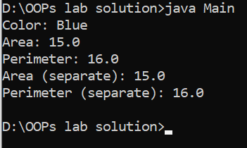
System.out.println("Perimeter (separate): " + r.getPerimeter());
}
}

Task No:2

class Animal {
private String name;

Animal(String name) {
this.name = name;
}

public String getName() {
return name;
}

public void makeSound() {
System.out.println("Makes a sound");
}
}

class Dog extends Animal {
private String breed;

Dog(String name, String breed) {
super(name);
this.breed = breed;
}

public void makeSound() {
System.out.println("Bark");
}

public String getBreed() {
return breed;
}

public void displayInfo() {
System.out.println("Name: " + getName());
System.out.println("Breed: " + breed);
}
}

public class Main {
public static void main(String[] args) {
Dog d = new Dog("Max", "Labrador");

d.makeSound();
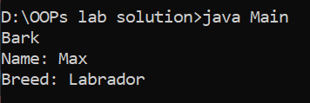
d.displayInfo();
}
}

Task No: 3
class Product {
private String productName;
private double price;

Product(String productName, double price) {
this.productName = productName;
this.price = price;
}

public double getPrice() {
return price;
}

public String getProductName() {
return productName;
}

public void getProductInfo() {
System.out.println("Product: " + productName + ", Price: " + price);
}
}

class DiscountedProduct extends Product {
private double discountPercent;

DiscountedProduct(String productName, double price, double discountPercent) {
super(productName, price);
this.discountPercent = discountPercent;
}

public double getPrice() {
double originalPrice = super.getPrice();
double discountedPrice = originalPrice * (100 - discountPercent) / 100;
return discountedPrice;
}
public void getProductInfo() {
super.getProductInfo();
System.out.println("Discount: " + discountPercent + "%");
System.out.println("Final Price: " + getPrice());
}
}

public class Main {
public static void main(String[] args) {
DiscountedProduct p = new DiscountedProduct("Mouse", 2000, 15);

p.getProductInfo();

System.out.println("Returned Price: " + p.getPrice());
}



